
Submitted by : Spogmai Jan
Roll no : 2430 -0081
Submitted to : mam yusra

Dsa lab 03:
Task 01:
- Write a program to sort an array [5,10,2,8,1,9,6] of integers using Selection Sort and
display the array before and after sorting.

#include <iostream>
using namespace std;

int main() {
int arr[] = {5, 10, 2, 8, 1, 9, 6};
int n = 7;

cout << "Array Before sorting: ";
for (int i = 0; i < n; i++) {
cout << arr[i] << " ";
}
cout << endl;

for (int i = 0; i < n - 1; i++) {
int min = i;
for (int j = i + 1; j < n; j++) {
if (arr[j] < arr[min])
min = j;
}
int temp = arr[i];
arr[i] = arr[min];
arr[min] = temp;
}

cout << "After sorting: ";
for (int i = 0; i < n; i++) {
cout << arr[i] << " ";
}
cout << endl;

return 0;
}

OUTPUT:
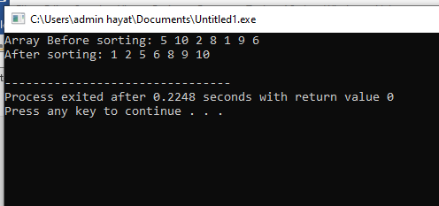
Task 02:
Write a program to perform Binary Search on an array [9,20,40,41,67,89,10,12,13,15].
Make sure the array is sorted through bubble sort algorithm before searching. Display whether
the element 89 is found or not, and its position if found.

#include <iostream>
using namespace std;

int main() {
int arr[] = {9, 20, 40, 41, 67, 89, 10, 12, 13, 15};
int n = 10;

// Bubble Sort
for (int i = 0; i < n - 1; i++) {
for (int j = 0; j < n - i - 1; j++) {
if (arr[j] > arr[j + 1]) {
int temp = arr[j];
arr[j] = arr[j + 1];
arr[j + 1] = temp;
}
}
}

cout << "Sorted array: ";
for (int i = 0; i < n; i++)
cout << arr[i] << " ";
cout << endl;

int target = 89;
int low = 0, high = n - 1, pos = -1;

// Binary Search
while (low <= high) {
int mid = (low + high) / 2;
if (arr[mid] == target) {
pos = mid;
break;
} else if (arr[mid] < target) {
low = mid + 1;
} else {
high = mid - 1;
}
}

if (pos != -1)
cout << "Element 89 found at position " << pos + 1 << endl;
else
cout << "Element 89 not found" << endl;

return 0;
}

OUTPUT:




